St. 2002, Sangkat Tektla, Khan Sen Sok, Phnom Penh, Cambodia

**Cover Letter**

Dear Sir or Madame,

I am writing this letter to express my profound interest in applying for the position of Technician which is currently available for Pantai Jerudong Specialist Centre (PJSC).

I am available Monday through Sunday. I'm flexible on start times I would need to finish by 6 pm. I am able to work additional hours if needed. I am confident that current working background would be effectively utilized in this position.

I feel that salary is negotiable which is in line with the industry average and reflects my skills and experience level well. I am, however, flexible and open to hearing about the company's compensation expectations for this position.

I am committed to my responsibilities and willing to do my best to complete all of the required works according to the company's policy.

I believe I would be an ideal candidate for the position and a valuable member to your company.

I am looking forward to hearing from you.

**Yours Sincerely,**

Phak Kearakvak. Relevant contact numbers

+855 92 615 577

Phaek Pheasa

**CURRICULUM VITAE**

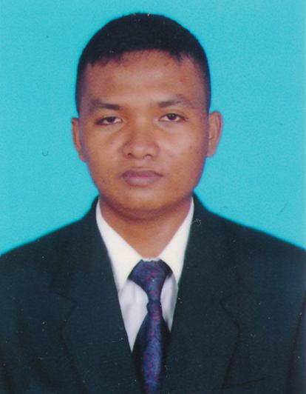

**Mr.: Phak Kearakvak**

Address: #St.2002, Tektla Commune,

Sen Sok District, Phnom Penh, Cambodia

Tel: +855 713338100

E-mail: [kearakvak06@gmail.com](mailto:kearakvak06@gmail.com)

**PERAONAL DATA**

Gender : Male

Nationality : Cambodian

Date of birth : 06/June/2000

Place of birth : Doeum Popel village, Thmor Et commune, Kampong Tralach district, Kampong Chhnang province.

**EDUCATION**

Royal University of Phnom Penh (RUPP) 2021-Present

*Information Technology*

Cambodian School of Prosthetics and Orthotics 2020-2021

*Prosthetics and Orthotics Technician*

Norodom Sihamoni High school 2019

*Bac II*

**WORK EXPERIENCES**

Exceed Worldwide Cambodia 2021-Present

*Prosthetics and Orthotics Technician volunteer*

**LANGUAGES**

Khmer English

*Native Fair*

**OTHER**

Characteristics: Honest, committed to work, good behavior, respect the rules and time, good moral and good communication in the work place.

**REFERENCE**

Name: Mil Bot

Position: Lecturer Intern DPO

Mobile: 093 696726

**DECLARATION**

I, Phak Kearakvak, would like to affirm all information given in the curriculum vitae is true to the best of my ability. If there is any false information, I am willing to take responsibility.



